**Implementing AWS Config Rules**

Step 1. Launch an EC2 Instance.

Step 2. After the successful lauching, click services tab and select AWS Config under Management Tools

Step 3. Click on Get Started.

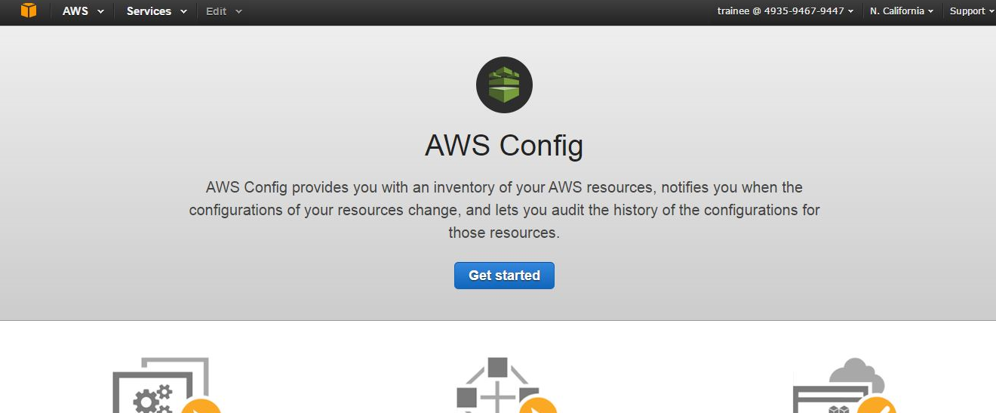

Step 4. Select the desired Resource types to record, by checking the box (i.e) Resources supported in region and resources supported by global

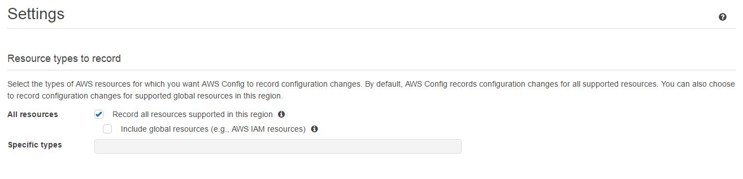

Step 5. Create new bucket or can select existing bucket to save all the recorded logs

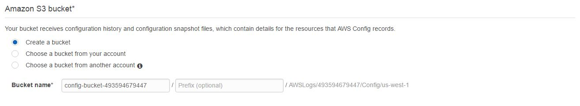

Step 6. Create SNS Topic

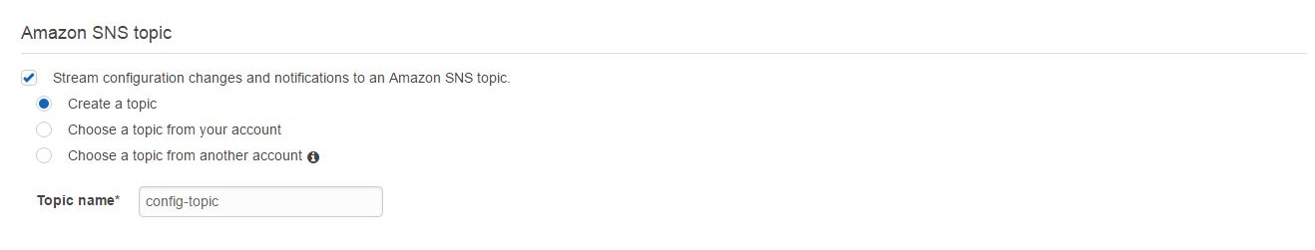

Step 7.Create AWS Config Role with read-only access.

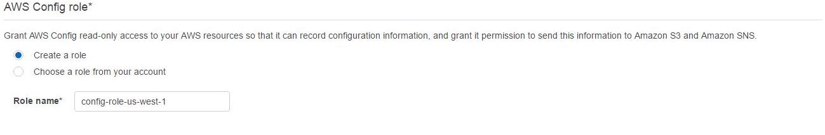

Step 8.In the Left Pane select Resources under resources drop down list and select the service (for example EC2 –instance and click on Look up

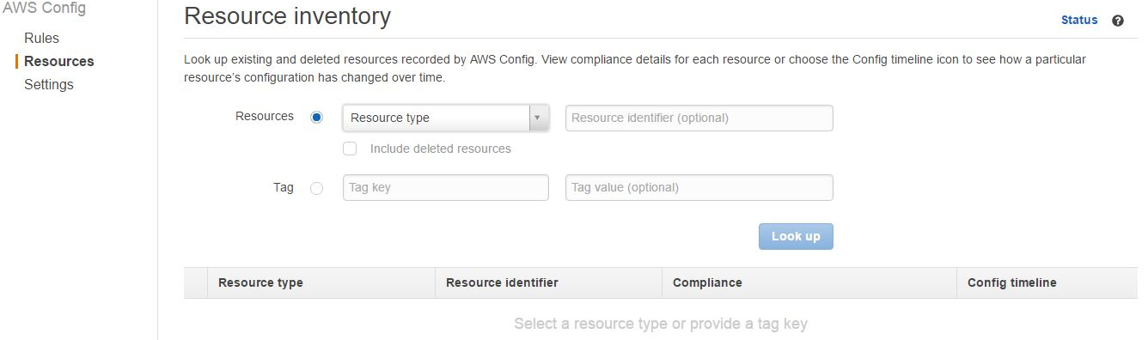

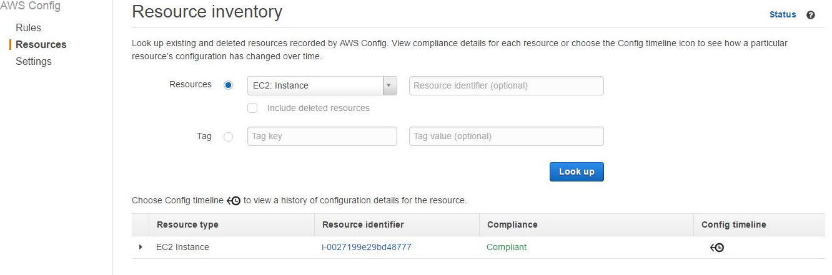

Step 9.Click on Config Timeline link to view configuration Details

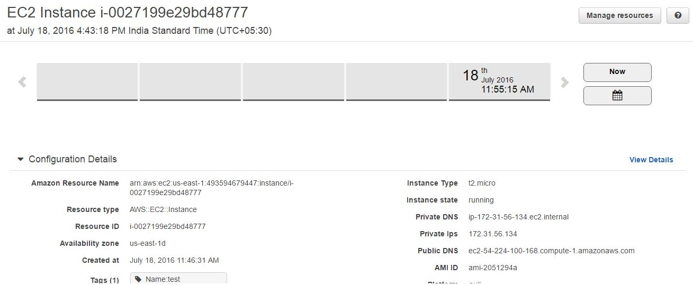

Step 10. Click on Rules, here we can add our own custom rule or select an existing rule.

If we select the custom rule write the code in lambda by using any of the program language like java, python, node.js and copy the ARN.

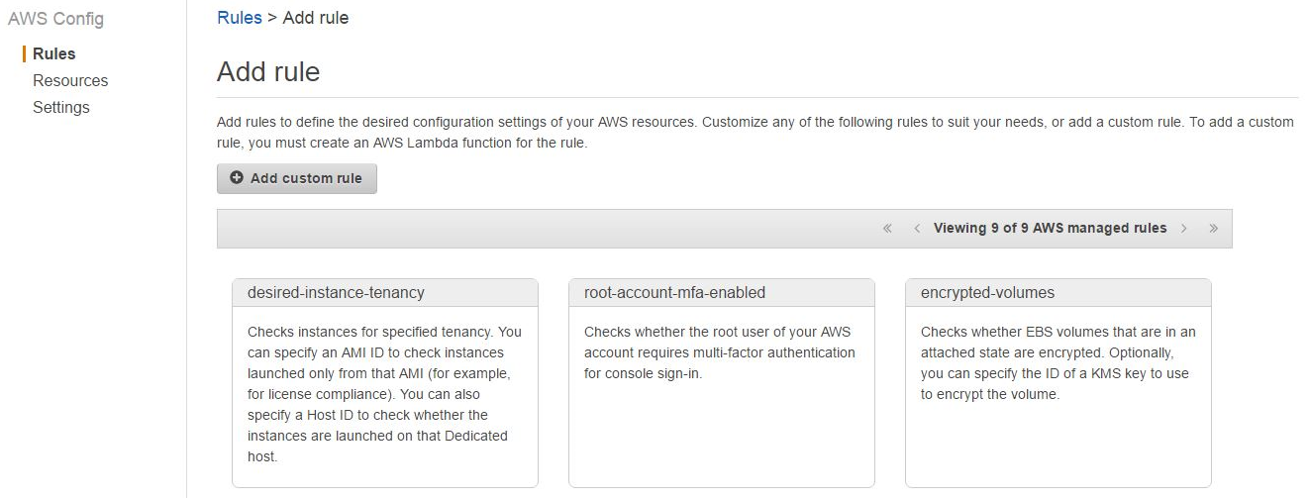

Step 11. Provide all the information and under trigger select trigger type and frequency to save date in S3 bucket. Click on save button

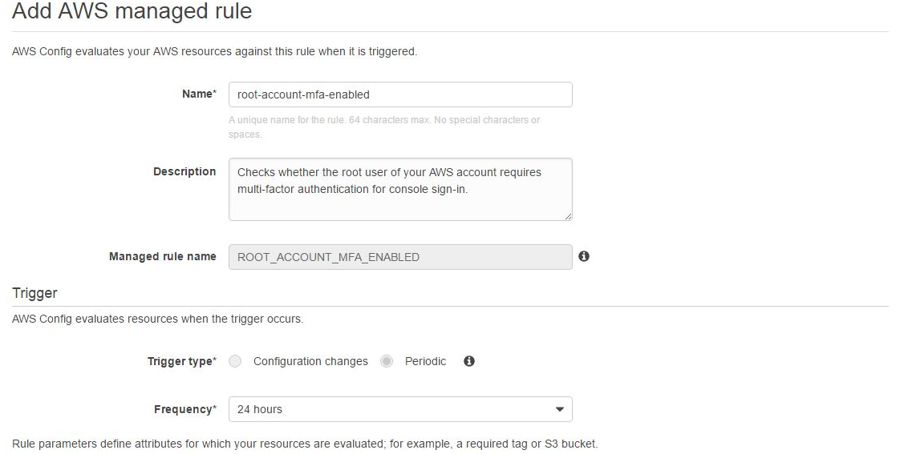

Step 12.Upon Successful compliance will change to complaint

